
The Arts Society Grayshott

The Art and History of Madrid and Toledo
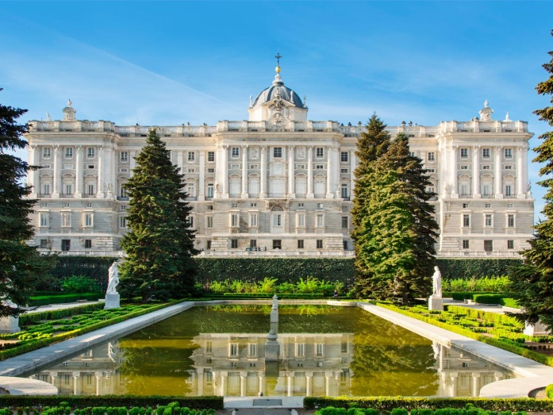
The following is the provisional itinerary for our 5 day tour to Madrid from 12 -16 May 2023. Details may be subject to change.
Friday 12 May Coach from Grayshott and Liphook to the airport. Fly to Madrid, where on arrival we will be met by our local guide and coach for transfer to our hotel and check in. Welcome drinks gathering followed by dinner at the hotel.

Saturday 13 May Panoramic City Tour, followed by visits to the Prado Museum, Spain’s world famous national gallery with not only the Spanish art collection but outstanding European art from the 12th to 20th C, and the Thyssen-Bornemisza Museum, regarded by many as the most important privately assembled art collection in the world

Evening at leisure

Sunday 14 May Visits to the Reina Sofia Museum, home to 20th C art, especially Picasso (including his famous Guernica), Dali, Miro and more, and
the Royal Palace, one of the most beautiful palaces in Europe.
Afternoon and evening at leisure

Monday 15 May A day in the historic city of Toledo including a complete guided tour of the many fascinating areas of the Cathedral, including the Royal Chapel, Bayeu paintings, Chapel of St Blas and amazing city views from the Bell Tower.

On return to Madrid in the evening, dinner at a local restaurant is included.

Tuesday 16 May A visit to the magnificent monastery and royal palace of El Escorial on our return journey to the airport (assuming flight times permit)
Flight Times (Easyjet from London Gatwick)
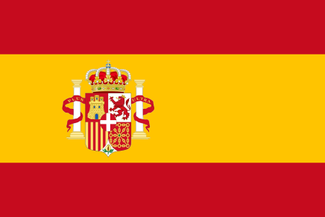
Outbound: Depart Gatwick 12.10 Arrive Madrid at 15.45

Inbound: Depart Madrid at 16.35 Arrive Gatwick at 18.00

